HP ALM 12.5 GFIT Framework Design

Contents

Document Version Control 3

Summary 4

The Principles 5

The Approach 5

The Sample Project 6

Supporting the Planning Activity 6

GFIT Framework Planning Nordea Test Strategy 3.0 section 5.1.1 6

Scope 6

Schedule 6

Requirements 7

Coverage 7

Supporting the Control Activity GFIT Framework Control NTS3 section 5.1.2 8

Test case preparation (percentage ready compared to plan) 8

Test case execution 8

Defect Management 8

Defect Transitions 9

Milestones 11

Progress 11

Supporting the Analysis and Design Activity 11

Prioritization 11

Traceability 11

Risk Based Testing 11

Supporting the Implement & Execute Activity Test Strategy 5.1.4 12

Appendix 2: Specific ALM Entity changes 13

Requirements 13

Test Plan 13

Test Lab 13

Management 13

# Document Version Control

|  |  |  |
| --- | --- | --- |
| Date | Author | Change Log |
| 10/1/2017 | Edward Moore | Initial draft |
| 18/1/2017 | Edward Moore | Agile discussion added |
| 28/9/2017 | Edward Moore | Outdated defect workflow removed and link added to the detailed defect workflow document. Added back in instructions on how to reinstate the permitted state lists if you ever want to put them back. |

# Summary

This document presents and explains the proposed structure for the Group Functions IT template ALM project.

An ALM template is a special project that allows central management of customizations, reporting, key performance indicators etc. which can then be applied to all projects linked to that template.

The objective is to support Nordea Test Strategy 3.0 and move to a standardised reporting methodology within Group Functions IT based on the scorecard functionality we now have from the application lifecycle management licence for waterfall type projects.

# The Principles

HP ALM is a complex tool and it carries a premium price tag. Organizations investing in the tool have a right to expect that users will leverage all the capability that this investment brings. Users, principally test managers, have a responsibility to deliver on this expectation.

The GFIT framework is designed to:

1. Facilitate this delivery, regardless of the personal skill level of a test manager with the ALM tool.
2. Increase the overall skill set of the Nordea talent pool with regard to ALM.
3. Deliver consistent KPI based reporting.
4. Build a consistent approach that will show strength, depth and consistency in tool use.

# The Approach

The GFIT framework will deliver on these designs with:

1. A Sample project constructed according to HP best practice that an incoming test manager can copy at a structural and logical level.
2. Detailed guide documents based on the HP Best Practice series.
3. Pre-Configured, automated reporting for all areas of the test strategy that can be automated.
4. Specific support for each of the test strategy activities, Planning, Design, Control and Execution.

# The Sample Project

The Group Functions IT Test Framework template will provide a sample project for users to base their own work on. This will be structured in a way to take advantage of the full feature set of ALM 12.5 and will include all ALM objects correctly linked for full traceability and reporting including risk based analysis and Key Performance Indicators

Providing a project that incoming test managers can copy will deliver a consistent ALM usage more effectively than any other means.

The template project will show how to fully comply with the Nordea Test Strategy 3.0, section by section.

Through this document we will examine each of the sections of the Nordea Test Strategy 3.0 and consider how the intention can be supported through effective and consistent use of the tooling provided.

# Supporting the Planning Activity

## GFIT Framework Planning Nordea Test Strategy 3.0 section 5.1.1

The planning activity is measured through key performance indicators. To support the planning activity we have created the following key performance indicators.

* GFIT Planning – NF Requirement Coverage
* GFIT Planning – Risk Analysis
* GFIT Planning – Test Coverage
* GFIT Planning – Tests Marked Ready

### Scope

Pre-configured project will show how to set up scope items properly in ALM 12.5.

There will be no customizations to the scope items. Scope item guidelines to be taken from the ALM Best Practice series document “Project planning and tracking best practices”

Scope items are associated with the key ALM Concept of the “Release”. Using a template based approach allows us to configure releases centrally; defining the test phases and cycles (but not dates or scope) and associated projects can then create a release from that central template which copies over all the cycles and phases.

### Schedule

Pre-configured project will show how test cycles, scope and milestones link to produce a schedule. The example project schedule looks like this:

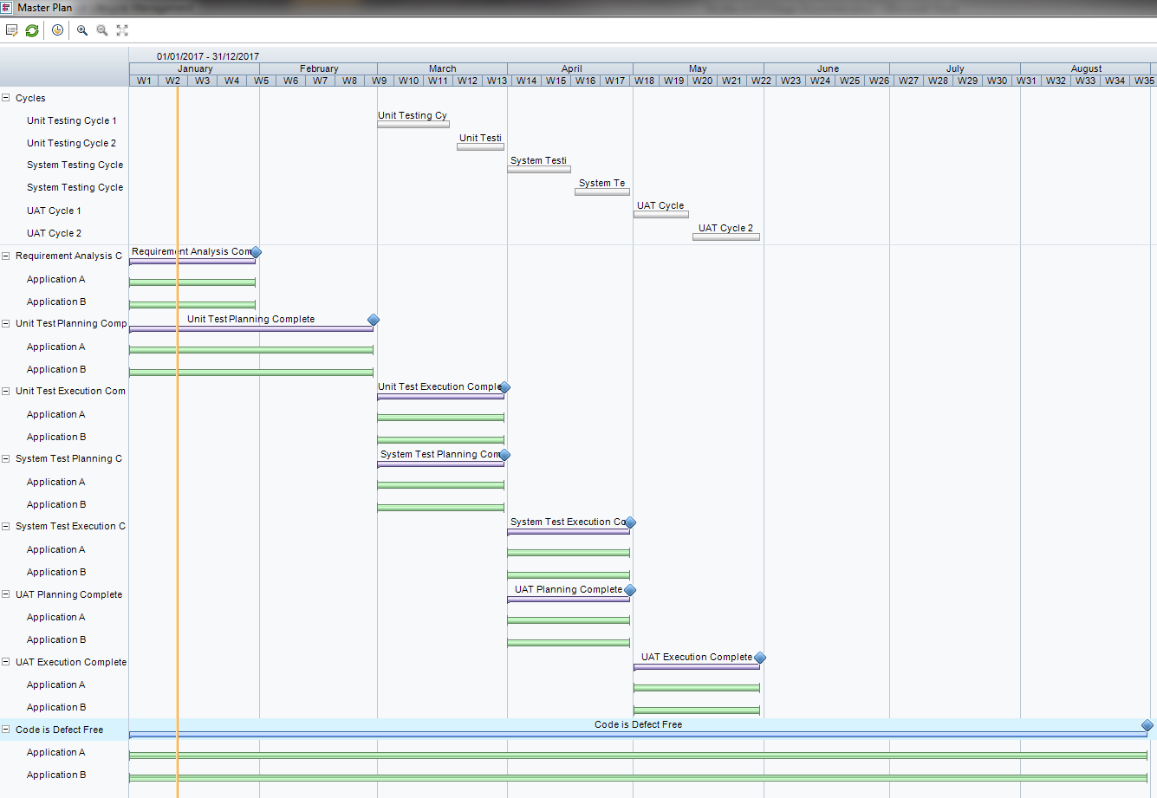

### Requirements

Pre-configured project will show how to correctly establish requirements and set up requirement traceability.

The requirement module will be populated using a standard upload template. (This probably already exists for version 11.5)

#### Requirements customizations

There will be a new requirement type of non-functional requirement. This requirement will have direct test coverage. This will replace the existing requirement “performance” consolidating all non-functional requirements in a single requirement type.

## Coverage

Coverage is part of the planning exercise. Coverage is ensured through mapping of requirement to test.

The GFIT Framework will include a report that identifies requirements that do not have cover and test cases that are not associated with a requirement. The Planning exercise KPIs are listed above.

# Supporting the Control Activity GFIT Framework Control NTS3 section 5.1.2

### Test case preparation (percentage ready compared to plan)

This will be a pre-configured report in the framework. It is used both as the quality gate “Test Cases have been revived and approved by Test Manager” and “test case preparation”. This duplication exists in the test strategy document.

### Test case execution

Tracking test case execution is done through the KPIs.

Configuration of Key Performance Indicators will be done at the GFIT level and applied consistently to all projects under the framework.

The following Key Performance Indicators have been created to support the Control Activity

* GFIT Control – Average Defects
* GFIT Control – Critical Defects’
* GFIT Control – Major Defects
* GFIT Control – Priority 1 test cases executed
* GFIT Control – Priority 2 test cases executed
* GFIT Control – Other test cases executed

KPIs are tuned to look at specific test levels through the optional filter control on the KPI implementation to a specific milestone.

## Defect Management

Test Strategy section 16 presents a defect management process that must be followed. This will be enforced through the defect workflow.

The method used for enforcing defect workflow is presented in a separate handover document located here:

Shared Documents\Projects\Test Process\20_HANDOVER\40_ALM\10_Handover Docs\GFIT Framework Defect Workflow HowTo.docx

If at any point you wish to reinstate the lists of permitted statuses this is the code that was used. This code would need to be pasted back into the defect workflow script in the section for “field change”. Someone competent with ALM workflow needs to do this.

'This is the code for defect workflow management implemented by Ed Moore in 2016

'It works by changing which list of allowed values is used in the drop down

dim currentstatus

currentstatus = Bug_Fields("BG_STATUS").Value

if currentstatus = "New" then

Bug_Fields("Status").List = Lists("bg_transitions_from_new")

elseif currentstatus = "Open" then

Bug_Fields("Status").List = Lists("bg_transitions_from_open")

elseif currentstatus = "Retest" then

Bug_Fields("Status").List = Lists("bg_transitions_from_retest")

elseif currentstatus = "Closed" then

Bug_Fields("Status").List = Lists("bg_transitions_from_closed")

else

Bug_Fields("Status").List = Lists("bg_transitions_from_any_reject_state")

end if

'End of Eds code for defect workflow

## Milestones

Milestones are a key component of the project planning and tracking and to an extent replace some of the “Test Cycle” functionality. The sample project will include milestones with associated scope items driving the key performance indicators.

## Progress

Progress in ALM 12.5 is measured using the release scorecard. The development of an effective release scorecard is the main objective of the proposals.

# Supporting the Analysis and Design Activity

## Prioritization

Test case prioritization is required by the test strategy and is required by two of the mandatory metrics. Test Priority is not a standard field and will have to be added as customization TS_TEMPLATE_USER_01

## Traceability

Traceability from requirement to test is *coverage* and as referred to above.

Traceability from requirement to requirement in parent & child relationships will be shown in the model project.

### Risk Based Testing

Nordea test policy states that risk based testing must be applied. In our assessment this is not being applied.

This is a challenging area. The configuration of risk based testing in ALM is not a simple exercise. The demonstration project will include full risk based analysis but in the longer term this policy statement should be weighed against the cost and consistency of implementation.

There is a KPI that measures the extent to which risk based analysis has been conducted on the project but it is not realistic to expect this will be used extensively.

It is also the case that the default “out of the box” configuration for risk based analysis is being used in ALM 12.5. This should be reviewed and adapted for Nordea if it is to be effectively used. This would require an assessment of what our internal risk factors actually are.

# Supporting the Implement & Execute Activity Test Strategy 5.1.4

The implementation and execution activity is focused on reporting progress back to the stakeholders and product owners.

Again this is to be achieved with the use of the scorecard within the project planning and tracking module.

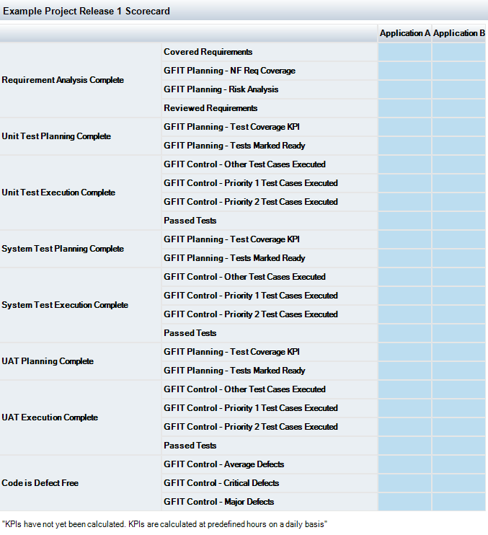

# Appendix 2: Specific ALM Entity changes

## Requirements

In the requirements module, on creation of a new requirement the fields “Old Type (Obsolete)” and “Product” will be removed for all Nordea groups through workflow script.

These fields are not required and clutter up the UI.

The default requirement type will be set to FUNCTIONAL not “undefined”

The “Performance” requirement will be renamed to “Non Functional”

To simplify upload path management we will create a folder directly under the top level of requirements called “Upload Target”. Requirements will be uploaded to this path and the users will be instructed to move them to where they should be.

## Test Plan

To support the GFIT Master Test plan section 2.1.2 dealing with quality gates a custom field for test priority will be created as TS_TEMPLATE_USER_01 / TEST PRIORITY so the quality gate metrics “x% of test priority 1 “ can be met. This will use the same list as the requirement priority measure.

To aid KPI reporting over test phases a custom field TS_USER_02 / Test Level will be created. This will use a new list “test levels” consisting of:

* Unit Testing
* System Testing
* User Acceptance Testing

To identify missing information we will create a report to identify tests with missing test level or priority.

We will not make these mandatory as it causes the creation of tests from requirements to be problematic.

## Test Lab

No additions or changes to test lab other than the creation of a default view with most columns removed for simplicity.

## Management

A number of Key Performance Indicators have been created as per the descriptions above.

# Agile

The discussion as to whether ALM 12.5 can be used to deliver an agile project is usually lively. On the one side there is the case that an agile project is doing exactly the same activities as a waterfall project, in a slightly different order and to a faster cycle pattern, and on the other side is the case that ALM does not *feel* agile and does not use the agile terminology, story pointing etc.

The fact remains that most, if not all of the functionality in a fully agile platform, such as Rally or ALM Octane can be reproduced in ALM 12.5, if in areas this is slightly harder to achieve.

The GFIT Framework has been extended to guide agile projects in using ALM 12.5 and all the analysis and reporting tools that brings, with an agile methodology.

This will deliver the same reporting capabilities using the same key performance indicators across GFIT regardless of the delivery methodology used.

The key is to map the existing ALM entities onto their agile cousins and explain how the agile cycle or sprint works with ALM.

## Specific Changes to support Agile

New requirement types “GFIT Agile Epic” & “GFIT Agile User Story”

In order to hide the Target Cycle and Target Release fields from view in the Epic requirement type some code will be used in workflow ( not yet implemented )

Custom Field on requirements RQ_USER_TEMPLATE_01: Agile Story Points, Lookup list on Fibonacci sequence numbers. This is not included in the requirement type definitions for anything other than the GFIT Agile User Story

Custom Field on requirements RQ_USER_TEMPLATE_02: Agile Team. String for now but pending testing could use lookup list although in the template project the list values will be blank to allow the project to populate their own list of team names. Does having a blank list in the template overwrite a populated list in the satellite when a propagation of customizations is done?

Custom field on requirements RQ_USER_TEMPLATE_03: Agile State. One validated value from “Analysis”, “Development”, “Testing” or “Complete”.

# Template Project Change Log

Template baseline taken on 9th February 2017.

|  |  |
| --- | --- |
| Feb 27th 2017 | GFIT Test manager can now delete test plan folders |
| Jan 19th 2017 | Test Managers & Project managers can delete releases |
| March 9th 2017 | Test Manager can delete test instances and manage both test plan and test lab. Cannot reset test sets and cannot delete run results. |
| April 7th 2017 | Test manager can delete resources |